Exhalation Control Valve Hardware Specification
PB 540

Table of Content

1.0 INTRODUCTION 3
1.1 Objective 3
1.2 Scope 3
1.3 Revision History 3
2.0 THEORY OF OPERATION 3
3.0 DESIGN REQUIREMENTS 4
3.1 Technology 4
3.2 Control voltage 4
3.3 Leakage 4
3.4 Power 4
3.5 Response 4
3.6 Dimensions 5
3.7 Pneumatic interface 5
3.8 Installation hardware 5
3.9 Installation location 5
3.10 Mounting surface 5
3.11 Electrical connection 6
3.12 Valve Life 6
3.13 Labelling / traceability 6
3.14 Weight 6
3.15 Packaging 6
3.16 Operating temperature 6
3.17 Gas temperature 6
3.18 Gas type 6

INTRODUCTION

Objective
The purpose of this document is to describe the requirements for the exhalation control valve for the PB 640, PB 560, PB 540 and PB 520 device.

Scope
This document describes the physical, functional and electrical requirements for the exhalation control valve for the PB 640, PB 560, PB 540 and PB 520 device.

Revision History
Revision | Date | Author | Change Description
A | 02 Jun 08 | J.C. Cabrera | Initial Release of Specification.
B | 03-Nov-2008 | G. Sanchez | Clarified operational requirements under control voltage.  Corrected Wire color.  Minor formatting changes

THEORY OF OPERATION

A 3 way valve will control the exhalation valve of the breathing circuit.
The exhalation valve will close during the inspiration (1➔2 opened).
The exhalation valve will open completely (2➔3 opened) or partially during exhalation to allow the patient to exhale and the exhalation valve will control the bias flow.

1
2
3
De-energised position
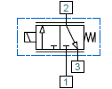
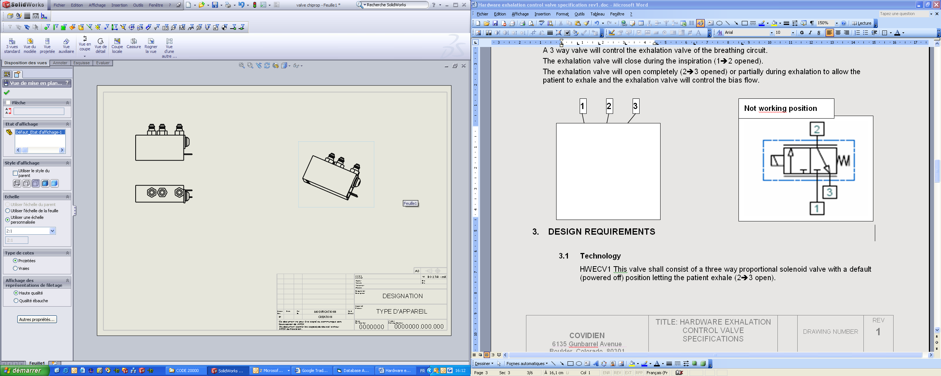

DESIGN REQUIREMENTS

Technology
HWECV1 This valve shall consist of a three way proportional solenoid valve with a default (powered off) position letting the patient exhale (2➔3 open).

Control voltage
HWECV2 The valve control voltage shall be from 0 to 24 VDC.
HWECV3 A flow rate of 0.3 L/min +/-0.1 L/min shall be generated from input 1 to output 2 when a pressure of 80mBar +/-1mBar and a current level of 17.5mA +/-3mA are applied.
HWECV4 A flow rate of ≥ 1.4 L/min shall be generated from input 1 to output 2 when a pressure of 80mBar +/-1mBar and a current level of 42mA +/-2mA are applied.
HWECV5 The flow shall be ≥ 1.1 L/min from output 2 to output 3 at 0mA and 80mBar +/-1mBar.

Leakage
HWECV6 The leakage from shall be < 0.1 L/min from input 1 to output 3 at 31mA +/-2mA and 80mBar +/-1mBar.
HWECV7 The leakage from shall be < 0.1 L/min from input 1 to output 2 at 0mA and 80mBar +/-1mBar.

Power
HWECV8 The maximum power shall be 1.12 W at 24VDC.

Response
HWECV9 The valve shall achieve full actuation in less than 10 ms at 44mA with 80 mbar of pressure.

Dimensions
HWECV10 The valve dimensions shall be the following:
Length = 28,5 ± 1 mm, Width = 10 ± 1 mm, Height = 22.4 ± 1 mm
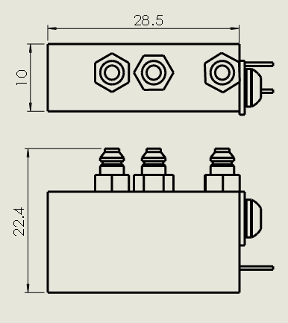

Pneumatic interface
HWECV11 The 3 pneumatic connections shall be as follows:
Ø inlet external diameter 2,3 ± 0,2 mm – External diameter 3,4 ± 0,2 mm –Height 7 ± 0,2 mm.
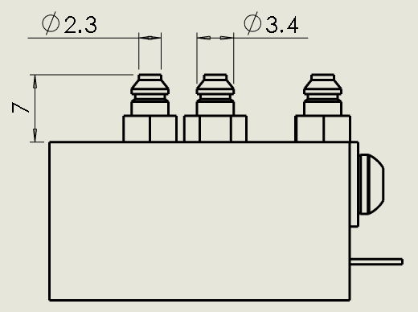

Installation hardware
HWECV12 The valve shall be secured with mounting hardware.

Installation location
HWECV13 The valve shall be located on an printed circuit board.

Mounting surface
HWECV14 The mounting surface of the valve shall be non-conductive.

Electrical connection
HWECV15 Electrical connections shall consist of two black wires Length 52 ± 5 mm / AWG 27 including connector (ZHR 2 type).

PIN NUMBER | SIGNAL NAME |  | PIN NUMBER | SIGNAL NAME
1 | Red wire (-) |  | 2 | Black wire (+)

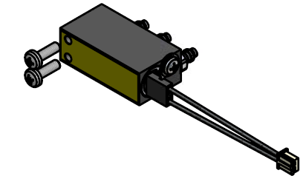

Valve Life
HWECV16 The life of the valve shall be ≥ 30 millions full open/close cycles.

Labelling / traceability
HWECV17 The valve shall be labeled with the manufacturer name, manufacturer part number with last revision and serial number with year (yy) / week (ww).
Fluid Automation
Systems SA
S142.0048a
yy/ww

Weight
HWECV18 The valve weight shall be less than 16g.

Packaging
HWECV19 The valve shall be shipped in an individual sealed bag.
HWECV20 Packaging shall be tested to the international standard ISTA2A.
HWECV21 Packaging shall be designed to minimize the level of waste and waste disposal as per the European Directive on handling waste packaging.
Certificate Of Compliance is required.

Operating temperature
HWECV22 The valve shall function within its specifications from 0°C to 50°C

Gas temperature
HWECV23 The valve shall be capable of operating with gas temperatures from 0°C to 50°C

Gas type
HWECV24 The valve shall be compatible for gas mixtures with up to 100% O2.

